OAuth 2.0 Contract Details: (Sample)

|  |  |
| --- | --- |
| GrantType | Authorization code |
| redirect URL/Callback URL | https://rahulshettyacademy.com/getCourse.php |
| Authorization server url | https://accounts.google.com/o/oauth2/v2/auth |
| Access token url | https://www.googleapis.com/oauth2/v4/token |
| Client ID | 692183103107-p0m7ent2hk7suguv4vq22hjcfhcr43pj.apps.googleusercontent.com |
| Client Secret | erZOWM9g3UtwNRj340YYaK_W |
| Scope | https://www.googleapis.com/auth/userinfo.email |
| State | Any random string |
| How to pass oauth in request | Headers |

**Step1:**

Mandatory fields for GetAuthorization Code Request ;

**End Point** : Authorization server url  
**Query Params**:Scope, Auth_url, client_id, response_type, redirect_uri  
  
output : Code

Example: (Or Manually hit this below URL and login with your gmail credentials you will get a code)

[**https://accounts.google.com/o/oauth2/v2/auth**?scope=**https://www.googleapis.com/auth/userinfo.email**&auth_url=**https://accounts.google.com/o/oauth2/v2/auth**&client_id=**692183103107-p0m7ent2hk7suguv4vq22hjcfhcr43pj.apps.googleusercontent.com**&response_type=**code**&redirect_uri=**https://rahulshettyacademy.com/getCourse.php**](https://accounts.google.com/o/oauth2/v2/auth?scope=https://www.googleapis.com/auth/userinfo.email&auth_url=https://accounts.google.com/o/oauth2/v2/auth&client_id=692183103107-p0m7ent2hk7suguv4vq22hjcfhcr43pj.apps.googleusercontent.com&response_type=code&redirect_uri=https://rahulshettyacademy.com/getCourse.php)

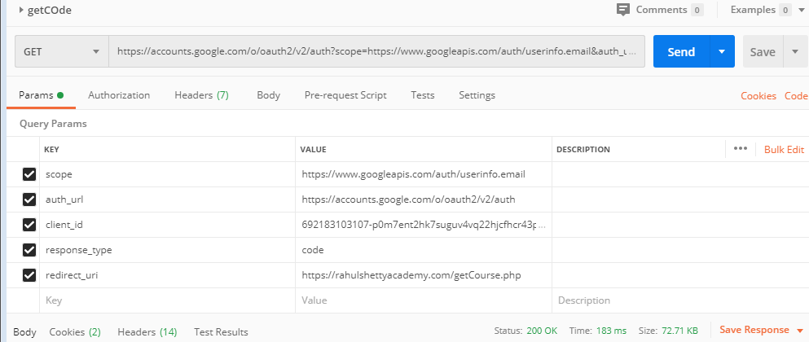

[https://rahulshettyacademy.com/getCourse.php?code=4%2FzAEkOYoupxpck_2c9MR90XwWQdTSExBOdkBIy9jyvQV1hDYHKd6kx3vADTA6A6hl5GfIXXDKWLMYQN3H2egZ9NQ&scope=email+https%3A%2F%2Fwww.googleapis.com%2Fauth%2Fuserinfo.email+openid&authuser=0&prompt=consent#](https://rahulshettyacademy.com/getCourse.php?code=4%2FzAEkOYoupxpck_2c9MR90XwWQdTSExBOdkBIy9jyvQV1hDYHKd6kx3vADTA6A6hl5GfIXXDKWLMYQN3H2egZ9NQ&scope=email+https%3A%2F%2Fwww.googleapis.com%2Fauth%2Fuserinfo.email+openid&authuser=0&prompt=consent)

Step2:

Mandatory fields for GetAccessToken Request :  
**End point** : Access token url

**Query Params** :Code, client_id, client_secret, redirect_uri, grant_type

Output : Access token